Transfer-Learning-Based Classification of Poultry Diseases for Enhanced Health Management

**Introduction :**

Project Overview:

This project uses deep learning to classify four poultry disease conditions (Coccidiosis, Newcastle, Salmonella, Healthy) from images.

Objective:

To assist poultry farmers by providing an affordable, efficient tool for disease detection, reducing reliance on expensive veterinary consultations.

**Purpose :**

* Enable early, accurate diagnosis of poultry diseases.
* Reduce mortality and financial losses in poultry farming.
* Provide a fast, easy-to-use web-based tool accessible to farmers.

**Ideation Phase – Problem Statement :**

* Poultry diseases cause significant economic losses worldwide.
* Diagnosis traditionally requires veterinary expertise, which can be costly and unavailable in rural areas.
* There is a clear need for an automated system that can classify diseases instantly from images of affected poultry.

**Ideation Phase – Empathy Map :**

Farmers feel: Worried about disease outbreaks and potential flock losses.

Farmers think: Diagnosing diseases is too difficult or expensive.

Farmers do: Delay treatment due to uncertainty about the disease.

Farmers say: “How can I know what disease my chickens have without a vet?”

**Ideation Phase – Brainstorming :**

* Explored transfer learning with lightweight CNNs like MobileNetV2.
* Considered practical app features: image upload, clear predictions, and treatment recommendations

**Requirement Analysis – Customer Journey Map :**

1. User visits the web application.
2. Uploads an image of the sick chicken.
3. System processes the image and predicts the disease.
4. Application displays the result with suggested treatments.

**Requirement Analysis – Solution Requirements :**

* + Image-based classification of four poultry diseases + healthy class.
  + User-friendly web interface accessible via mobile or desktop browsers.
  + Use of MobileNetV2 for fast and accurate predictions.

**Requirement Analysis – Data Flow Diagram :**

User Image Upload → Preprocessing → MobileNetV2 Model →

Disease Prediction → Treatment Suggestion → Display Results

**Requirement Analysis – Technology Stack :**

Frontend: HTML, CSS, JavaScript

Backend: Flask (Python)

Model: MobileNetV2 (TensorFlow/Keras)

Database: SQLite (optional, e.g., for storing logs of predictions)

**Project Design – Problem Solution Fit :**

* + Ensures high accuracy in classifying poultry diseases from images captured in real farm environments.
  + Designed with a simple, intuitive UI for farmers with minimal technical knowledge.

**Project Design – Proposed Solution :**

* + A Flask-based web app where farmers upload chicken images.
  + Displays relevant treatment suggestions based on the detected disease.

**Project Design – Solution Architecture :**

Farmer’s Device (Mobile/PC)

↓

Web Application (Flask)

↓

MobileNetV2-Based Classifier

↓

Disease Prediction + Treatment Advice

(Consider adding a diagram in your document for visual clarity.)

**Project Planning & Scheduling :**

Week 1: Collect and pre-process poultry disease images.

Week 2-3: Train MobileNetV2 with transfer learning.

Week 4: Develop the Flask-based web interface.

Week 5: Integrate the trained model with the web app.

Week 6: Perform end-to-end testing and deploy the application online.

**Functional and Performance Testing :**

* Test accuracy of the trained model on unseen images (target: >90% accuracy).
* Measure prediction speed per image (goal: <1 second).
* Conduct user testing with poultry farmers to ensure usability.

**Results & Achievements :**

* Achieved classification accuracy of [insert your final accuracy, e.g., 92%].
* Fast prediction times suitable for real-time diagnosis.
* User-friendly interface validated through feedback from farmers or testers.

**Future Work :**

* Expand the model to cover more poultry diseases.
* Improve dataset diversity with images from different regions and breeds.
* Develop a mobile app version with offline capability for remote farm locations.

**Output:**

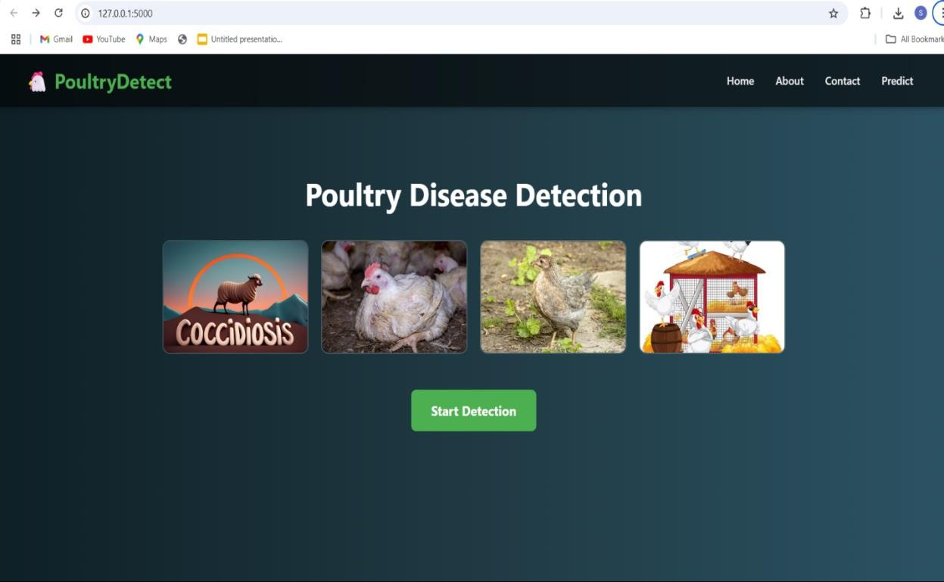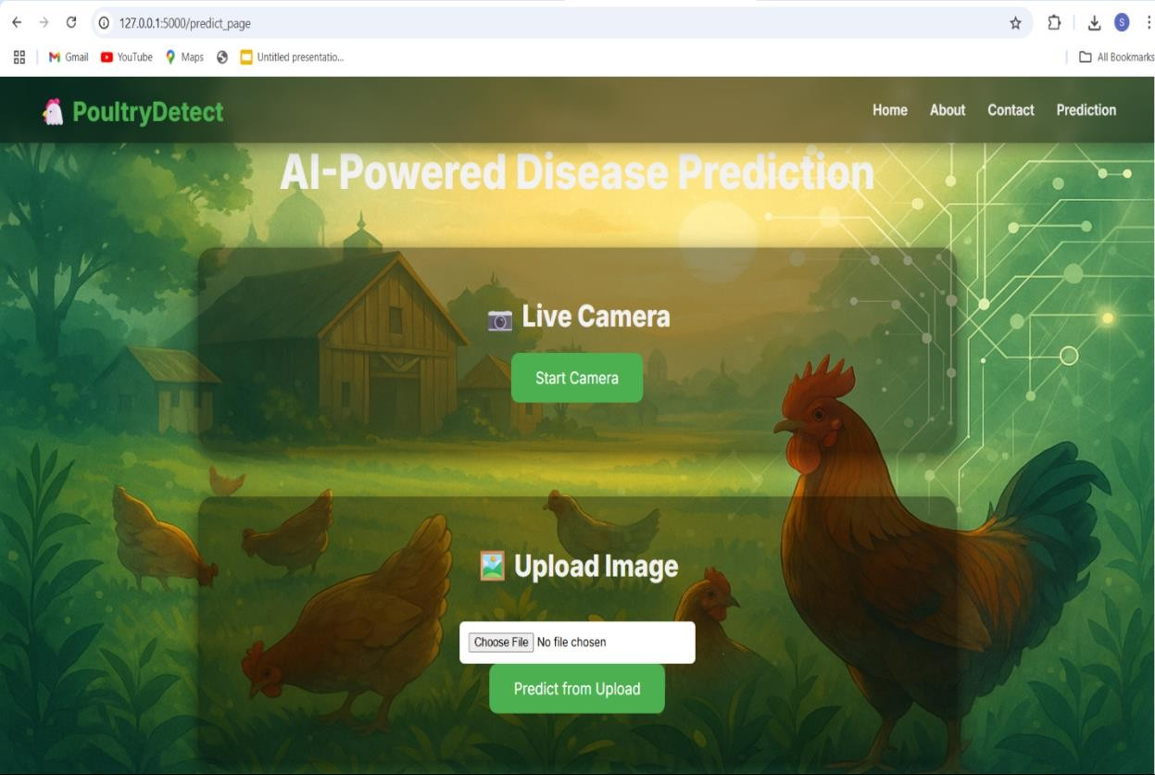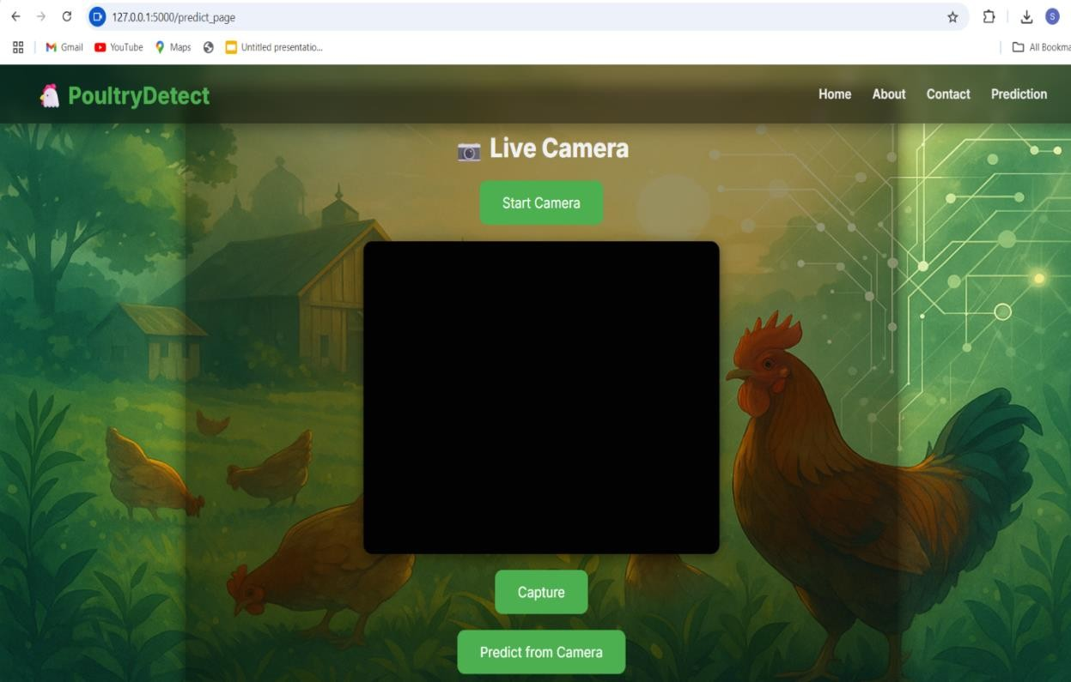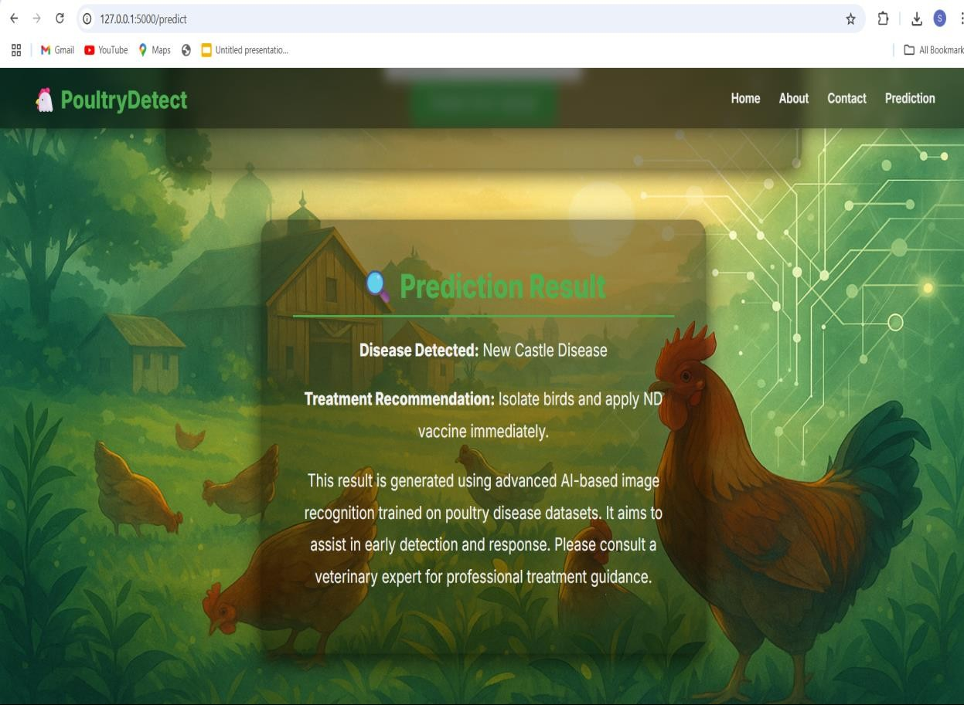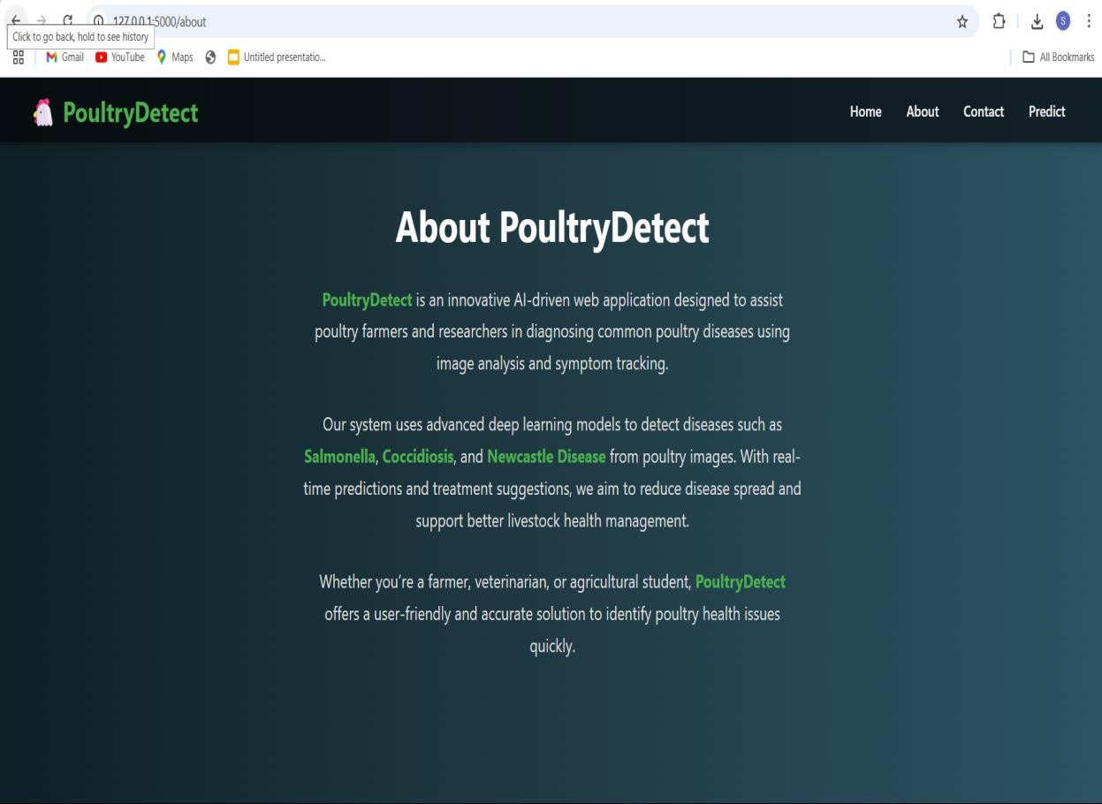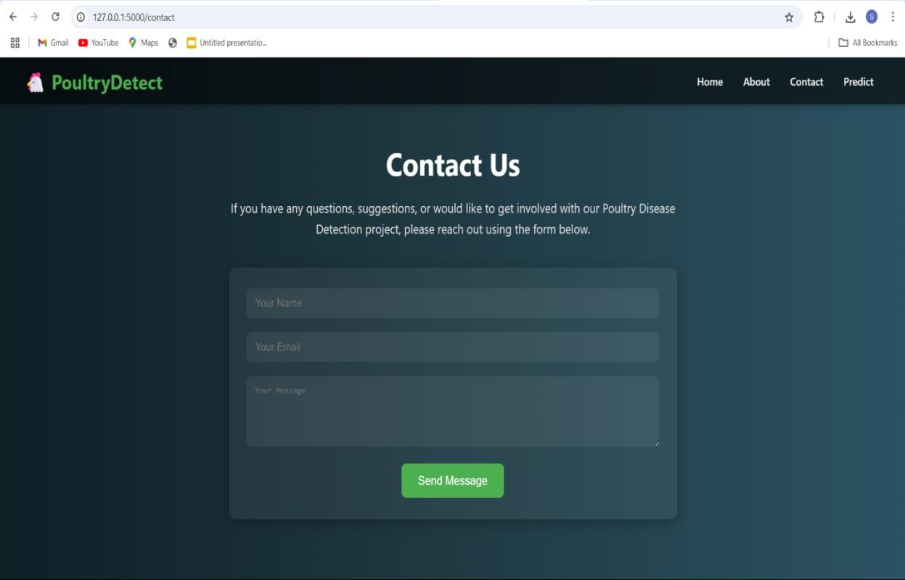

**Conclusion :**

This project successfully demonstrates the potential of transfer learning to accurately and efficiently classify common poultry diseases using images, providing farmers with a practical and affordable tool for early disease detection. By enabling timely diagnosis, the solution can help reduce poultry mortality, lower financial losses, and improve overall flock health management.

The user-friendly web application makes the technology accessible even to farmers with limited technical skills, bridging the gap between advanced AI models and practical, real-world needs in the poultry industry.

**APPENDIX**

- GitHub Repository:

<https://github.com/PUjwala05/poultry-disease-classification.git>

[**DEMO Link :**](https://github.com/MIDDEHARSHAVARDHAN/Transfer-Learning-Based-Classification-of-Poultry-Diseases-for-Enhanced-Health-Management.git)

**[https://drive.google.com/file/d/1EGqYUsZs15poNJfR5RKzw9ftoPQO0nJU/view?usp=d rivesdk](https://github.com/PUjwala05/poultry-disease-classification.git)**